Automated BOL Printout Form

Written By: Alaa Afifi
Release 01 – 08/01/2005
ITSOFT_DOC_02

Table of contents:

1. Narrative 4
2. System Environment Analysis 4
2.1. Problem Analysis 4
2.2. Technical Information 4
3. System Improvement Objective 4
4. Business Analysis 4
4.1. Business Process 4
4.2. Business Rules 4
5. Application Flowchart Error! Bookmark not defined.
6. Solution Analysis 5
6.1. Description 5
6.2. Actors Error! Bookmark not defined.
6.3. Functional Requirement 5
6.4. Non-Functional Requirement 9
6.5. Scenarios 9
6.6. Advantage 9
6.7. Disadvantage 9

Project Name: Automated BOL Form
Related Software: Aria2.7 EDI

Customer Name: GMA Accessories
Location: NJ

Project Manager: Alaa Afifi
Client Name: Ranjan Singh / Shipping Dept
Business Owners: Mike Altirs
Performing Organization: Aria System
Initiate by: Ranjan Singh
Written By: Alaa Afifi
Written Date: 8/1/2005
Expected Due Date: TBA

Approval By:
Approval Reference:
Approval Date:

- Narrative
To develop a program that enables the user to print a VICS standard B.O.L form automatically by either selecting the Electronic B.O.L number Or the Invoice number(s) and pull the info from Aria database.

- System Environment Analysis
  - Problem Analysis

Currently, the standard BOL form is done manually which is a time consuming process and subject to errors. Most of the info needed is already in Aria.
  - Technical Information

Operating System: Windows 2000
Resources:
Software Prerequisite:
Database:
User Interface:
Programming Language:
Constraints:
Users:
Security Policy:

- System Improvement Objective
Print a standard B.O.L form automatically based on BOL info Or Invoice info and pull the related info from the order/invoice in Aria.

- Business Analysis
  - Business Process

BOL printout process is done after either generating the electronic BOL or invoicing the Sales Order.
  - Business Rules

- Apply the VICS standard BOL format to all customers (even the non-EDI accounts).
- Apply the 17-digit BOL# when needed (this apply to EDI accounts only).
- Apply the 6-digit invoice# as alternative BOL# (in case of non-EDI accounts only)

- Solution Analysis

  - Description

Design a Graphic form layout for the standard BOL and pull the needed info from Aria’s BOL/invoice when applicable. The user should be able to do some modifications to the info before printing.

  - Functional Requirement

The new Automated BOL form will be a custom version of the current GMA BOL. The form will consist of 2 major portions (see layout attached):

- The BOL 1st page: will hold the header info and summary by Customer PO#
- The Supplement To The BOL: this will print on the 2nd page the details by Store/DC

Options Grid:

Option Name | Type / Description | Rules / Procedure
Select By: | Dropdown: BOL or Invoice | This will decide if we’ll print the BOL# or the Invoice# and where to pull the info from.
Account: | In List: select an account | Filter on a specific account
Invoice#: | In List: select a range or multiple invoice #’s | Conditioned on the ‘Select By’ option
BOL#: | In List: select a range or multiple BOL #’s | Conditioned on the ‘Select By’ option
BOL# Format: | Dropdown: 6-digit / 17-digit | Applicable only when ‘Select By’ -> BOL  (see the rules for the 17-digit BOL# under ‘Layout Description’ paragraph)
Print: Summary / Detail | Dropdown: Summary / Details | This will control the way the carton info will show up on the ‘Supplement To the BOL’ page:  Summary: will consolidate Cartons & Weight by customer PO# showing the totals only.  Details: will show up Carton & Weight details by Store# for the related orders/stores on the 2nd page (Supplement to the BOL).
Date Created: | Date input field: (Date format)  This will default to the current system date with ability to modify to any other date. | This date will print on the form for the selected BOL as the ‘Date Created’ – see layout.
Ship From | In List: show up the list of Locations (Finished Goods locations only) to select one location from. | This will print on the form as the ‘SHIP FROM’ address.  If it’s different from the Location saved on the BOL / Invoice selected, a warning message will show up, still allowing the user to continue printing.
Special Instructions: | Input field: (alphanumeric – 3 lines, 40 chars each line) | Print in the ‘Special Instructions’ section on the layout.
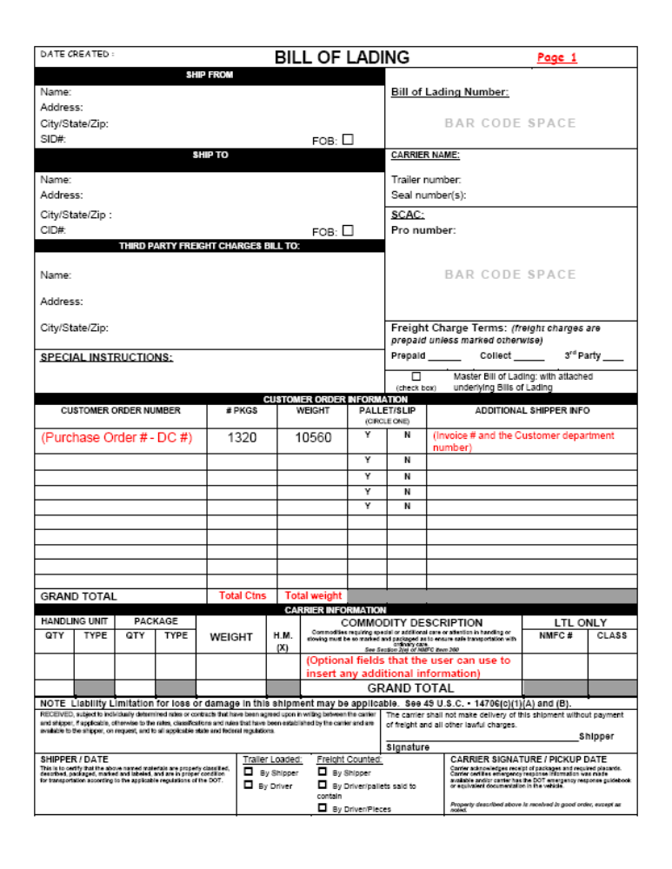

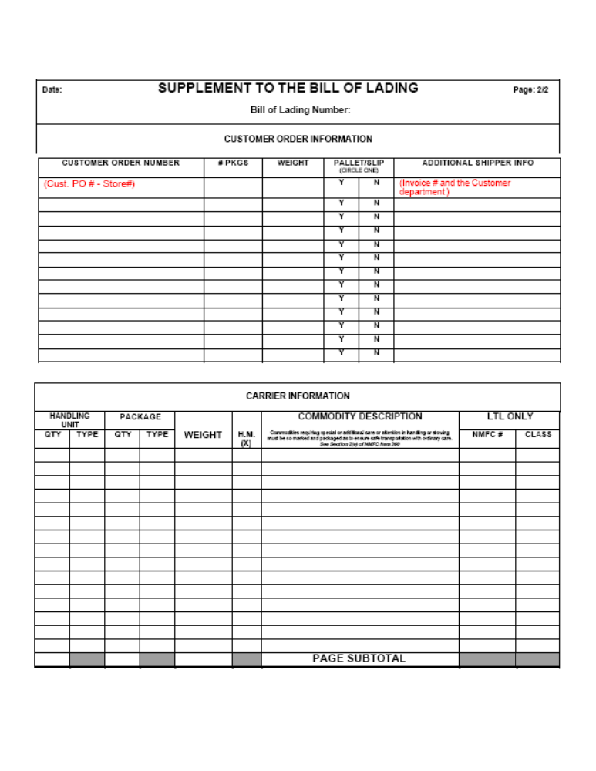

Layout Description:

Field Name | Description | Rules / Procedure
Date Created | Print the Date entered in the Option Grid | If no Date entered, print the actual Date saved on the BOL/Invoice
Ship From | Print Location address selected in the Option Grid. | If no Location is selected, print the actual Location address on the BOL (or the invoice)
Bill of Lading Number | Print BOL# or Invoice# (based on the Option Grid selected)  - See Rules/Procedure | - 6-Digit BOL#: is the actual BOL# saved in Aria database.  - 17-digit BOL#: this # will be calculated based on the following segments and logic: (UCC#+000+BOL#+Check Digit)  The Check Digit is calculated by:  (1) Adding the digits in the Odd position and multiply by 3  (2) Adding the digits in the even position  (3) Add the sum in point 1 & 2  (4) Subtract point 3 from the nearest multiple of 10  Example:  B.O.L # 130346 will become 07419850001303463  0 7 4 1 9 8 5 0 0 0 1 3 0 3 4 6  numbers are in the odd position : 0+4+9+5+0+1+0+4=23 X 3=69  Even position numbers : 7+1+8+0+0+3+3+6=28  Sum of Point 1 & 2 : 69 +28 = 97  Nearest multiple of 10 to 97 is 100  100- 97 = 3  the check digit is 3  - Invoice#: This will be the 1st invoice# in the selected range of invoices.
Ship To | Print the customer Ship To address | Ship To is either the store or the DC address of the selected BOL (or invoice)
Carrier Name | Print Ship Via description | Ship Via description on the selected BOL (or invoice)
SCAC | SCAC code | Print from the related fields of the Ship Via code.
Pro number | Leave empty | to be filled manually
Third Party Freight Charges Bill To | Leave empty | to be filled manually
Special Instructions | Print from instructions field entered in the Option Grid | Free text – 3 lines, 40 chars each line
Freight Charges Terms | Leave empty | to be filled manually
Customer Order Number | Summary: Print Customer PO# only.  Details: Print Customer PO# and Store# for each P/L (or Invoice) on the 2nd page. | The summary by PO# will always print on the 1st page of the BOL.  The Details by Store will print on the 2nd page (Supplement to the BOL) only when Details is selected in the Option Grid.
# PKGS | Total Cartons summarized by customer order# consolidated from the related P/L’s (or range of invoices) | Print summary by order on the 1st page and details by Store on the 2nd page
Weight | Total Weight summarized by customer order# consolidated from the related P/L’s (or range of invoices) | Print summary by order on the 1st page and details by Store on the 2nd page
ADDITIONAL SHIPPER INFO | Print the related range of invoice# and the customer Dept # for each order included in the BOL | Summary: Print range of invoice# (from - to)  Details: Print each invoice# in front of the related store# on the 2nd page (Supplement to the BOL).
GRAND TOTAL | Total Weight and Cartons | Total Weight and Cartons for all orders on the selected BOL (or Invoices)
CARRIER INFORMATION | Leave this section empty | to be filled manually
SHIPPER DATE | Leave this section empty | to be filled manually

  - Non-Functional Requirement

N/A
  - Scenarios

N/A
  - Advantage

- Save time and reduce human errors that result from the manual entry of information.

  - Disadvantage
- Cannot keep track of an electronic BOL in case the user selects to print by Invoice#
- In case of select by Invoice#, user has to select the correct invoice# range that is shipped to one customer location, and by the same Ship via / carrier.

